Structural Bioinformatics Approach to Design Boradamantane-derivates Compounds as SARS-CoV-2 Inhibitors

Arli Aditya Parikesit^{1,*}
¹Department of Bioinformatics, School of Life Sciences, Indonesia International Institute for Life Sciences, Jl. Pulomas Barat Kav.88 Jakarta 13210 Indonesia
*Corresponding author: aril.parikesit@i3l.ac.id

- Motivation

Up until today, there is no designated drug that could inhibit SARS-CoV-2 virus effectively in the market (Drew & Janes, 2020). The utilization of the boraadamantane compounds are considered to be a solution for the COVID-19 drug design effort because it is previously working with other coronaviruses, and other respiratory virus such as influenza virus. Moreover, the organometalloid compounds are still underutilized in COVID-19 research, so it is considered as a novel approach (Hartinger et al., 2012).
With more than 250 million positive cases and the fatality rate approaching 6 million, COVID-19 is the most pressing global challenge that must be resolved immediately(WHO, 2020). More than 600 clinical trials on various types of repurposed drugs and drug candidates are being carried out around the world focusing on testing the effectiveness of these compounds. We pick the 1-boraadamantane and derivates compounds first because this molecule class is the most abundant among boraadamantanes(Bourque et al., 2015).
The scientific objective of this research is to prove that the adamantane boron (boraadamantane) based compounds could be elicited as feasible drug candidates for COVID-19. Boraadamantane compounds have been shown to elicit antiviral activity in the lab assay. Moreover, the technological objective of this project is to provide a prototype of drug candidates that is ready for the clinical trial (Bourque et al., 2015; Zarin et al., 2016).
The novelty of this research is the utilization of inorganic-based boron compounds, the boraadamantane, as drug candidates for COVID-19 with a nanotechnology approach (Figure 1). Based on the current literature, the adamantane-based compounds have successfully inhibited both dengue and influenza viruses in the in vitro setting(Fort & von Schleyer, 1964; OI et al., 1993; Tanner et al., 2005; Wei et al., 2009). However, there are no conclusive studies yet for adamantane-based compounds in the inhibition of the SARS-CoV-2 virus. Although dengue, influenza, and coronavirus are from a different viral species, it is worth exploring whether the adamantane-based compounds, especially the boron-enriched one, could be applied to inhibit SARS-CoV-2 virus as well, at least in the in vitro setting. Based on previous research, the adamantane compound is known to inhibit the helicase enzyme in the SARS virus (One of the coronavirus families) as well (Tanner et al., 2005).
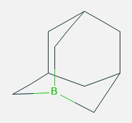

Figure 1: The example of the Boraadamantane compound, 1-Boraadamantane (Taken from https://pubchem.ncbi.nlm.nih.gov/compound/3297691#section=Structures )

- Methodology
The methodology was inspired and modified from exisiting pipeline(Arba et al., 2020; Bakri et al., 2014; Natalia & Tambunan, 2019; Tambunan et al., 2016, 2019; Vanmeert et al., 2019)
- Deep Learning Validation: The Big data annotation of drug database will be employed to determine whether the adamantane boron is a suitable drug candidate for COVID-19. This method will screen for millions of lead compound, including the boraadamantane, to validate the previous biological claim. Search for the ‘1-boraadamantane’ and derivates SDF and JPEG files in the pubchem database (https://pubchem.ncbi.nlm.nih.gov/). Convert the SDF files into PDB, and minimize their energy with optimize geometry function in avogadro (specific parameters should be devised). Rough 3D geometry was built automatically
- QSAR Analysis: It is required to determine whether the Adamantane boron compounds can bind to the selected protein. We expect that they will bind to the helicase enzyme, but it should be tested. The QSAR analysis will make sure that the adamantane boron will bind to a specific protein target. Deployed parameters: Force field: UFF; Steps per update: 4; Algorithm: Steepest Descent; Need 10 minutes for each ligand. Use PASS QSAR server to predict the biological reactivity of the ligand, and search for the possible antiviral activity http://www.pharmaexpert.ru/passonline. The Downloaded SMILE format annotations of the ligands was uploaded to the server.
- Sequence Analysis: The protein sequences will be downloaded from the NCBI website. After the protein target is determined, it is necessary to determine the protein domain that the drug candidate will bind to. This information is necessary to comprehend the evolutionary function of the protein annotation.
- Structural Analysis: The availability of the protein structure will be searched in the RCSB database (www.rcsb.org). If there are no available protein structures, the homology modeling method will be employed. This method is important to predict the unknown 3D structure of a protein based on the existing 3D templates in the available database. Use UCSF Chimera tools to add hydrogen and optimize geometry of the PDB file (specific parameters should be devised). Use grep "^ATOM" complex.pdb > protein.pdb to clean the protein from organic molecules, water, and buffer. Because water, ligand, and ions entry in the PDB always start with HETAM. To make sure, compare the complex PDB with the clean PDB in Chimera. Use ‘addH’ parameter in structure editing menu. Parameters: Consider each model, consider H-bond, and residue name based. Use ‘minimize structure’ parameter in structure editing menu. Parameters: Steepest decent steps: 100; Steepest descent step size: 0.02; Conjugate gradient steps: 10; Conjugate gradient step size : 0.02; Update interval:10; Fixed atoms: none; Checked ‘Memorize options”
- Ligand and Protein Preparation: The library of the adamantane boron compounds will be downloaded from both Pubchem (https://pubchem.ncbi.nlm.nih.gov/) and drugbank (https://www.drugbank.ca/) database. Then, the compounds data will be curated with marvinsketch or chemsketch application to determine whether their structural and atomic curation are correct. The same procedure will be applied for the protein structure as well. This method is important to ensure that both the ligand and protein structural data is ready for the next steps. Search for ‘SARS-CoV-2 Helicase’ (based on wet lab) and ‘SARS-CoV-2 Protease’ (Golden standard in SARS-CoV-2 Molecular simulation) enzymes in the PDB database (http://www.rcsb.org/)
- Molecular Docking: This method will be useful to examine whether the adamantane boron compound can bind to the targeted protein. If they bind well, the dynamics simulation can be utilized to further elaborate the binding. Use the standard ligand of docking. Utilize 5,6,7-trihydroxy-2-phenyl-4H-chromen-4-one (PDB ID: 3WL) as the standard, because it docked naturally to the 3CL Protease enzyme. Use PDB ID: 6m2n. Use patchdock version beta 1.3 application. Clustering RMSD: 4 angstrom. Complex type: default.
- Molecular Dynamics: This method is useful to examine the stability of the protein-ligand binding. If the stability test was passed, it can proceed to the wet laboratory experiment.

- Result and Discussion

Based on the QSAR Analysis, the protocol has shown that all compounds got “3C-like protease (Human coronavirus) inhibitor” properties in significant direction. Based on wet experiment, 3C-like protease enzyme is generic in a sense that the inhibitor could bind to the others as well. In this regard, forwarding to the molecular docking simulation is doable.
The Molecular Docking protocol shows that all the compounds could bind stronger and better to the SARS-CoV-2 Helicase enzyme than the standard (Figure 2). This is a good gesture that the compounds could be potentially applied in the in vitro setting. In the figure 2, the selected compounds were elicited with the PUBCHEM CID annotation that could be searchable in the PUBCHEM database.

a)  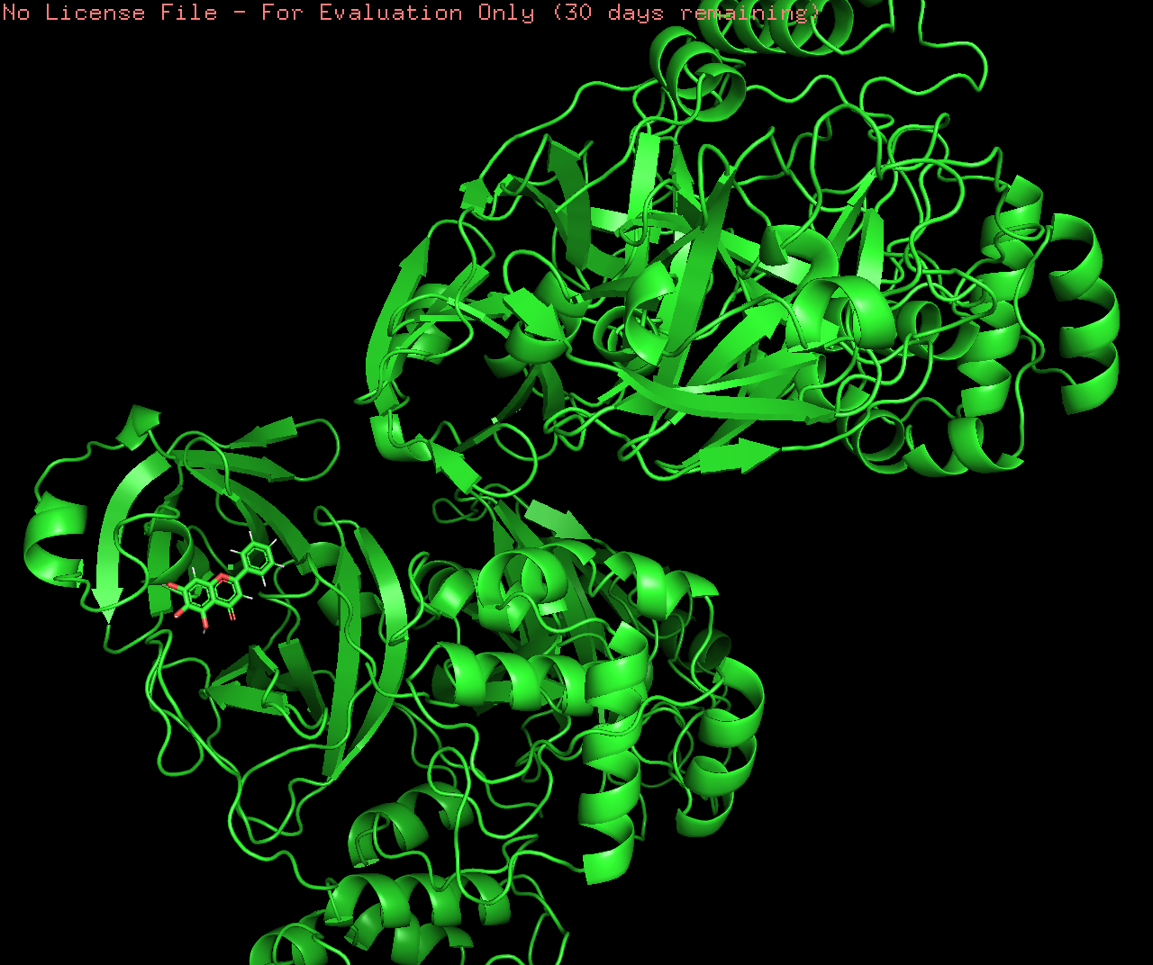 | b) 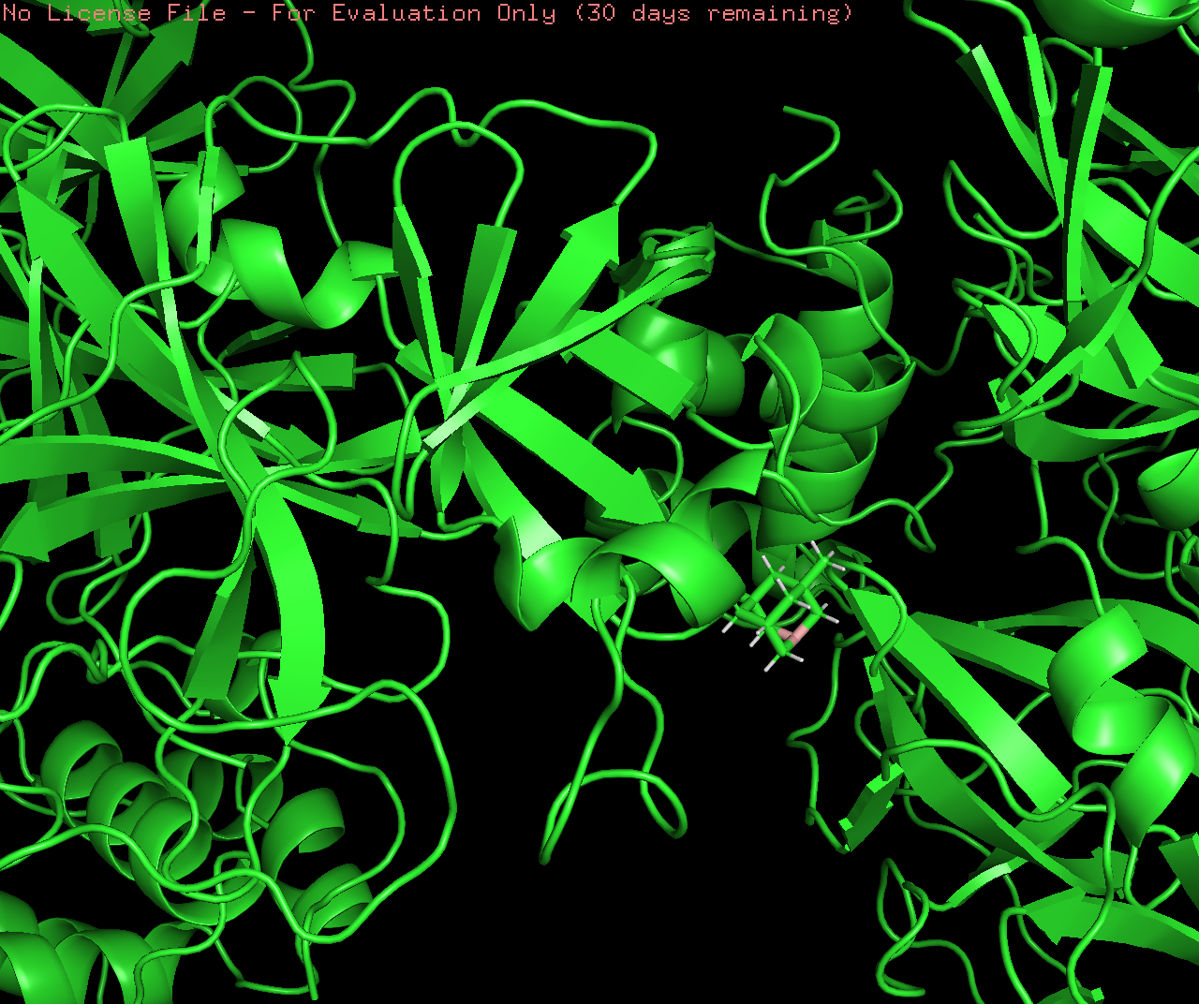
c)  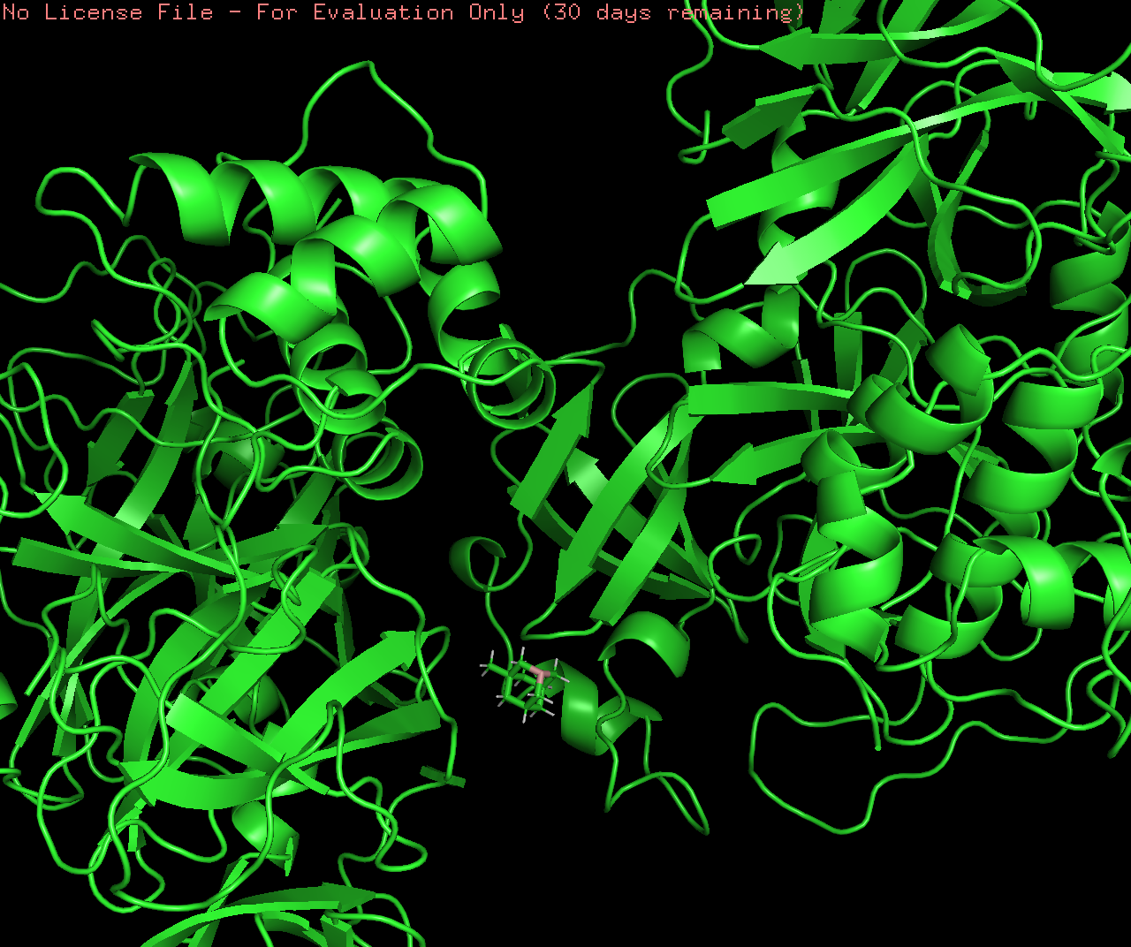 | d) 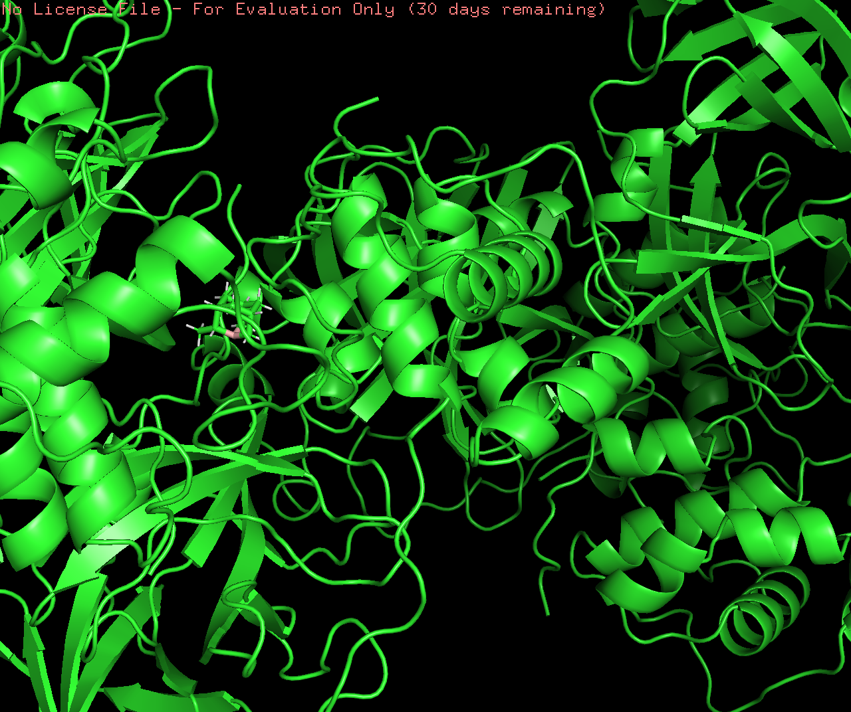
e)  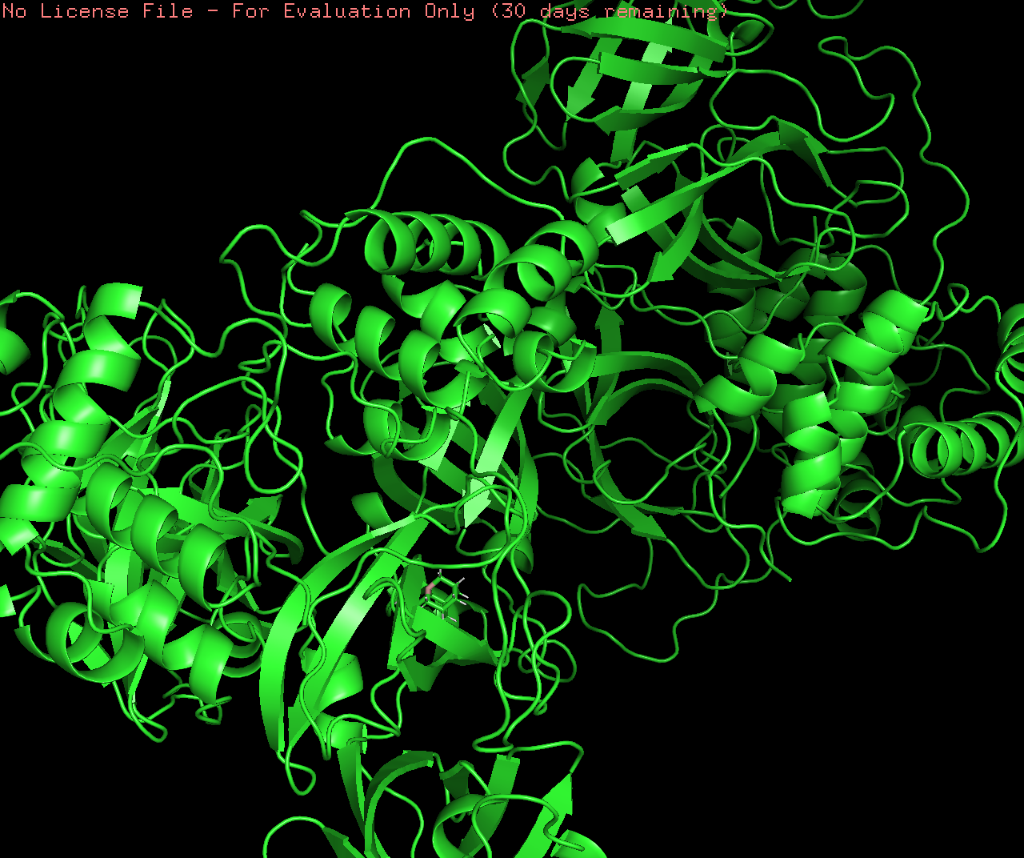 | f)  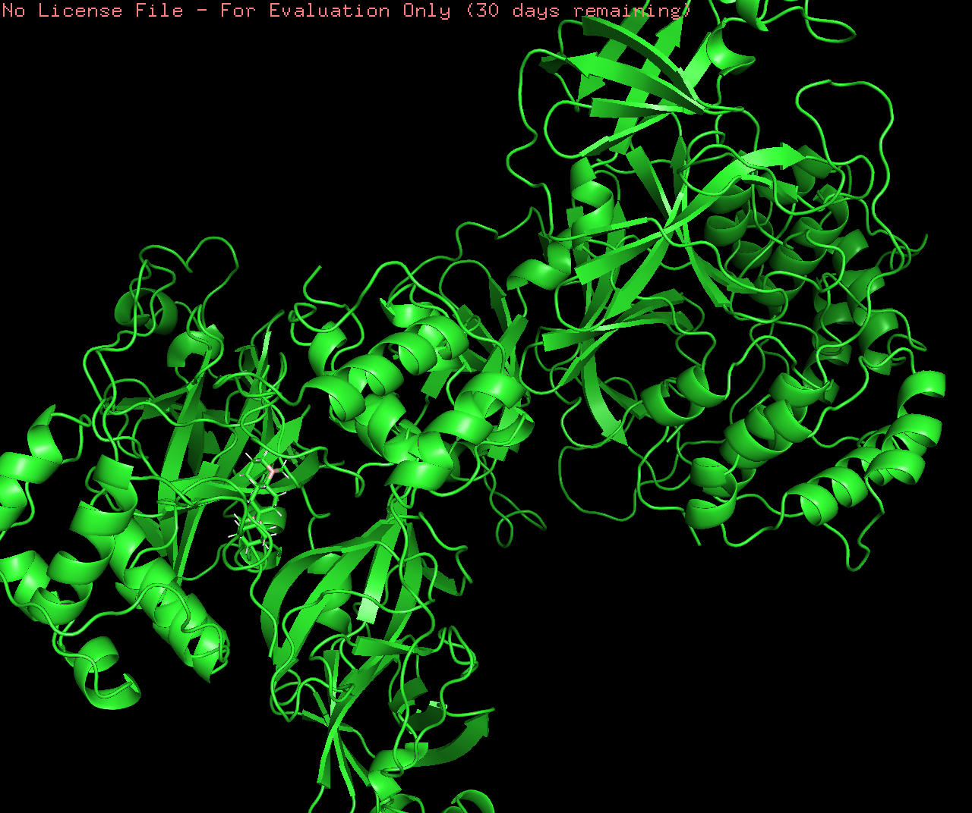
g)  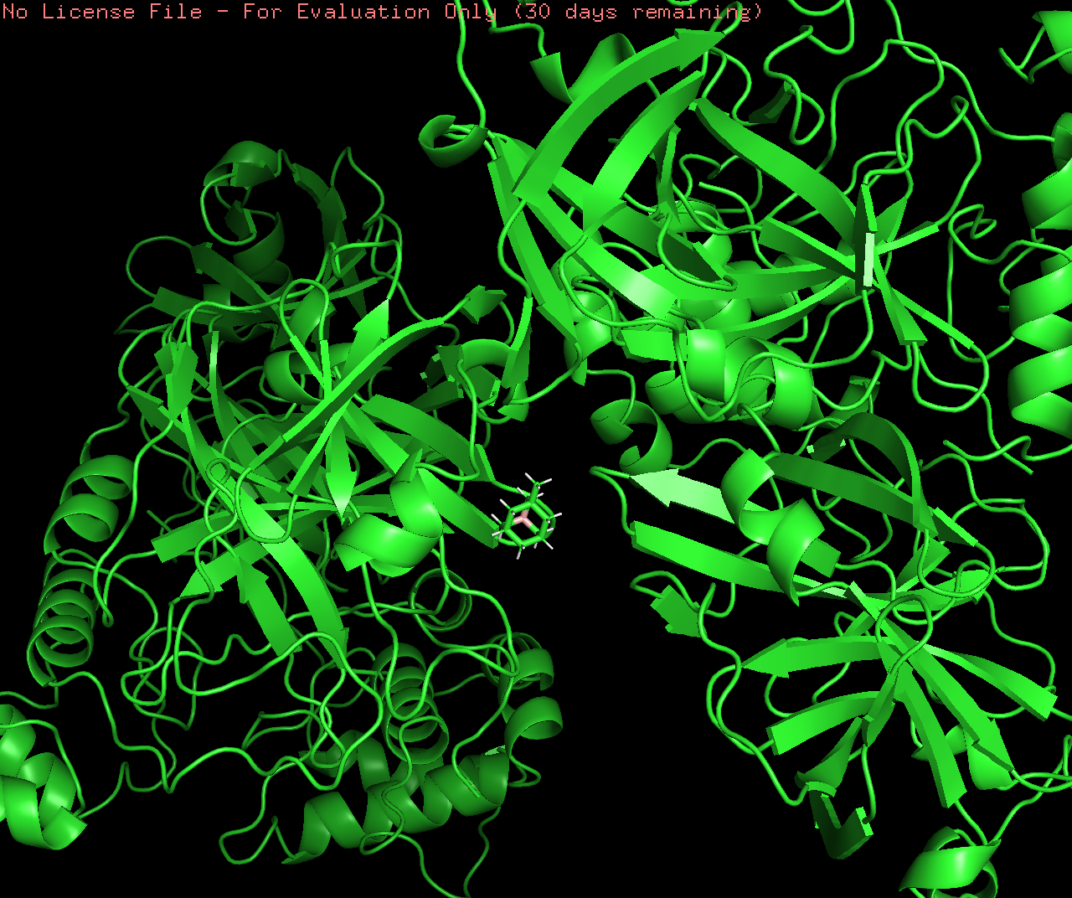 | h)  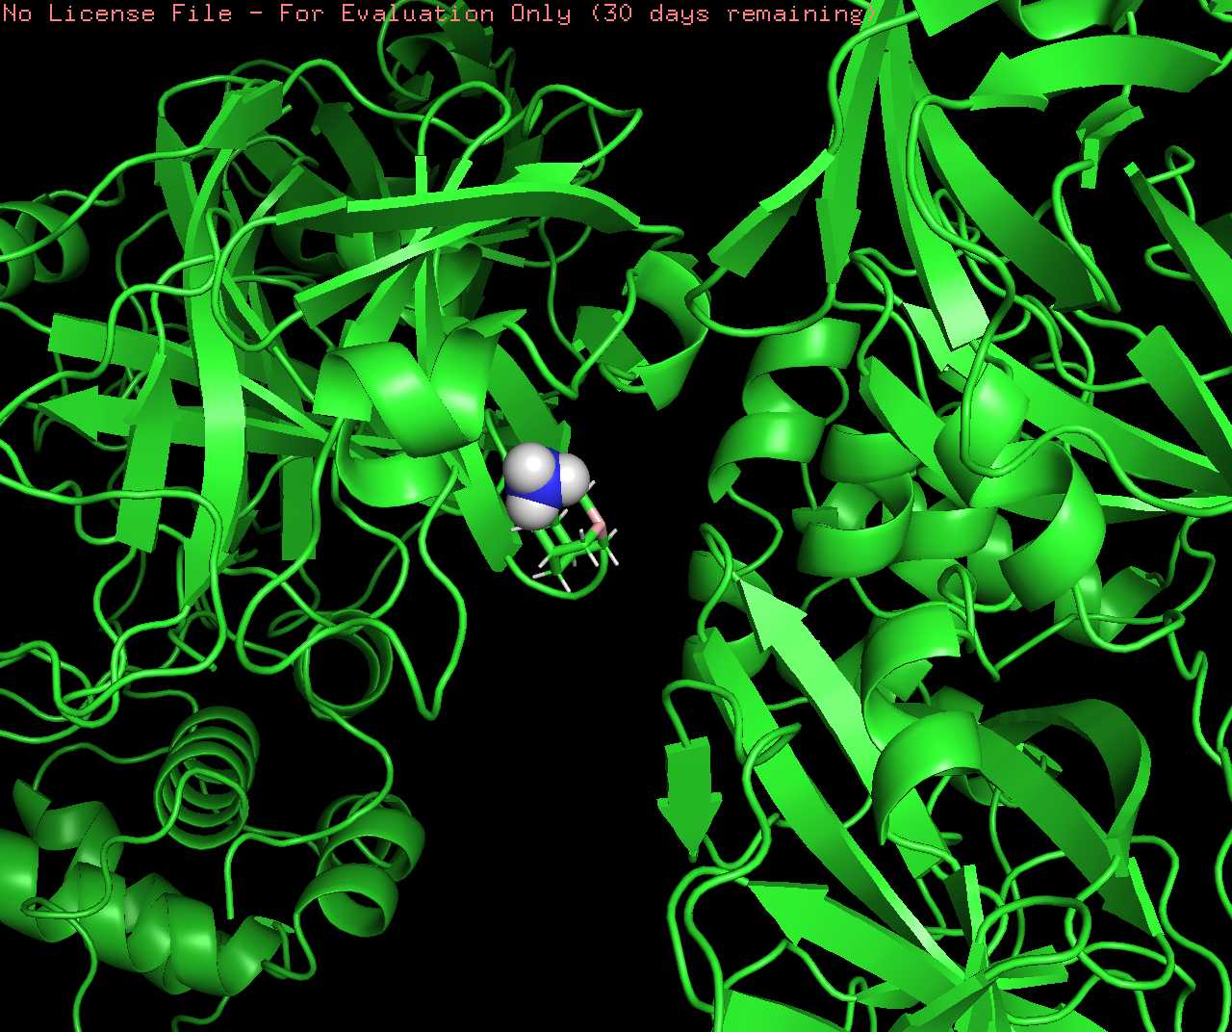

Figure 2 : Helicase enzyme of SARS-CoV-2 docking with a) 3WL standard b) Compound CID_12539988 c) CID_90924256 d) CID_100957746 e) CID_100957747 f) CID_101342362 g) CID_101483853 h) CID_129879284

- Provisional Conclusion
The protocol could produce a fine-grained adamantane borane derivate compound with the SARS-COV-2 helicase enzyme. However, tuning the parameter for a deeper QSAR analysis and molecular simulation are necessary to improve the fidelity of the pipeline, and for preparing the in vitro experiment accordingly.

- Acknowledgement
The author would like to thank to Iwan Surjawan.PhD and Taruna Ikrar PhD for the constructive discussion regarding this organo-borane based protocol. Thanks also go to Department of Innovation and Entrepreneurship of Indonesia International Institute for Life Sciences for their heartfelt support.

Reference

Arba, M., Nur-Hidayat, A., Usman, I., Yanuar, A., Wahyudi, S. T., Fleischer, G., Brunt, D. J., & Wu, C. (2020). Virtual Screening of the Indonesian Medicinal Plant and Zinc Databases for Potential Inhibitors of the RNA-Dependent RNA Polymerase (RdRp) of 2019 Novel Coronavirus. Indonesian Journal of Chemistry, 20(6), 1430. https://doi.org/10.22146/ijc.56120
Bakri, R., Parikesit, A. A., Satriyanto, C. P., Kerami, D., & Tambunan, U. S. F. (2014). Utilization of boron compounds for the modification of suberoyl anilide hydroxamic acid as inhibitor of histone deacetylase class II Homo sapiens. Advances in Bioinformatics, 2014. https://doi.org/10.1155/2014/104823
Bourque, J. L., Geier, S. J., Vogels, C. M., Decken, A., & Westcott, S. A. (2015). Synthesis and reactivity of novel boranes derived from bulky salicylaldimines: The molecular structure of a maltolato compound. Crystals, 5(1), 91–99. https://doi.org/10.3390/cryst5010091
Drew, E. D., & Janes, R. W. (2020). Identification of a druggable binding pocket in the spike protein reveals a key site for existing drugs potentially capable of combating Covid-19 infectivity. BMC Molecular and Cell Biology, 21(1), 1–13. https://doi.org/10.1186/s12860-020-00294-x
Fort, R. C., & von Schleyer, P. R. (1964). Adamantane: Consequences of the diamondoid structure. Chemical Reviews, 64(3), 277–300. https://doi.org/10.1021/cr60229a004
Hartinger, C. G., Metzler-Nolte, N., & Dyson, P. J. (2012). Challenges and Opportunities in the Development of Organometallic Anticancer Drugs. Organometallics, 31(16), 5677–5685. https://doi.org/10.1021/om300373t
Natalia, A. H., & Tambunan, U. S. F. (2019). Screening of terpenoids as potential therapeutics against Zaire ebolavirus infection through pharmacophore-based drug design. F1000Research, 8, 1040. https://doi.org/10.12688/f1000research.19238.1
OI, K., VM, B., KN, K., VI, I., VG, P., ON, C., MA, S., & VA, K. (1993). [The molecular mechanism of the action of antiviral preparations in the adamantane series]. Vestnik Rossiiskoi Akademii Meditsinskikh Nauk, 3, 10–15.
Tambunan, U. S. F., Bakri, R., Parikesit, A. A., Ariyani, T., Puspitasari, R. D., & Kerami, D. (2016). In silico modification of Zn 2+ binding group of suberoylanilide hydroxamic acid (SAHA) by organoselenium compounds as Homo sapiens class II HDAC inhibitor of cervical cancer. IOP Conference Series: Materials Science and Engineering, 107(1), 012054. https://doi.org/10.1088/1757-899X/107/1/012054
Tambunan, U. S. F., Parikesit, A. A., Ghifari, A. S., & Satriyanto, C. P. (2019). In silico identification of 2-oxo-1,3-thiazolidine derivatives as novel inhibitor candidate of class II histone deacetylase (HDAC) in cervical cancer treatment. Arabian Journal of Chemistry, 12(2), 272–288. https://doi.org/10.1016/j.arabjc.2015.07.010
Tanner, J. A., Zheng, B. J., Zhou, J., Watt, R. M., Jiang, J. Q., Wong, K. L., Lin, Y. P., Lu, L. Y., He, M. L., Kung, H. F., Kesel, A. J., & Huang, J. D. (2005). The adamantane-derived bananins are potent inhibitors of the helicase activities and replication of SARS coronavirus. Chemistry and Biology, 12(3), 303–311. https://doi.org/10.1016/j.chembiol.2005.01.006
Vanmeert, M., Razzokov, J., Mirza, M. U., Weeks, S. D., Schepers, G., Bogaerts, A., Rozenski, J., Froeyen, M., Herdewijn, P., Pinheiro, V. B., & Lescrinier, E. (2019). Rational design of an XNA ligase through docking of unbound nucleic acids to toroidal proteins. Nucleic Acids Research, 47(13), 7130–7142. https://doi.org/10.1093/nar/gkz551
Wei, H., Wang, C.-H., Du, Q.-S., Meng, J., & Chou, K.-C. (2009). Investigation into adamantane-based M2 inhibitors with FB-QSAR. Medicinal Chemistry (Shāriqah (United Arab Emirates)), 5(4), 305–317. http://www.ncbi.nlm.nih.gov/pubmed/19689387
WHO. (2020). Therapeutics and COVID-19. https://apps.who.int/iris/bitstream/handle/10665/336729/WHO-2019-nCov-remdesivir-2020.1-eng.pdf
Zarin, D. A., Tse, T., Williams, R. J., & Carr, S. (2016). Trial Reporting in ClinicalTrials.gov - The Final Rule. The New England Journal of Medicine, 375(20), 1998–2004. https://doi.org/10.1056/NEJMsr1611785

